This source code is licensed, not sold, and is subject to a written license agreement. Among other things, no portion of this source code may be copied, transmitted, disclosed, displayed, distributed, translated, used as the basis for a derivative work, or used, in whole or in part, for any program or purpose other than its intended use in compliance with the license agreement as part of the QualNet software. This source code and certain of the algorithms contained within it are confidential trade secrets of Scalable Network Technologies, Inc. and may not be used as the basis for any other software, hardware, product or service.

SCENARIO PURPOSE: Provide a Scalable Scenario with DEM terrain defined with proper coordinates and available background image.

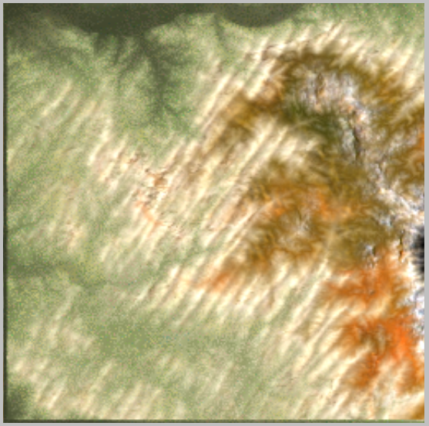SCENARIO:

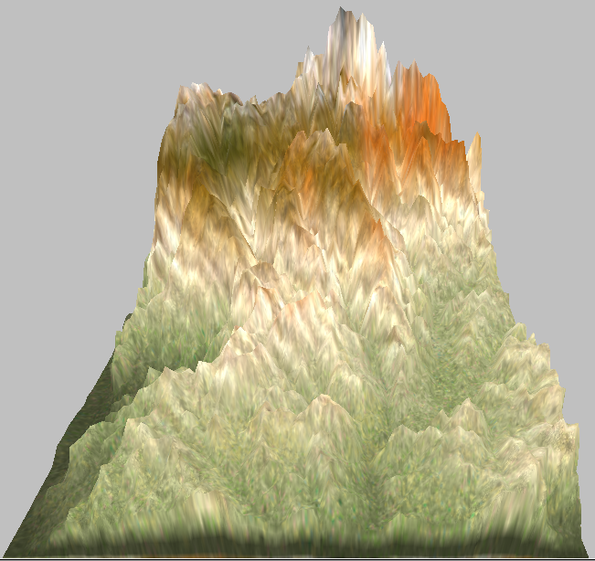

This scenario is meant to be a “template” and has no network topology defined. It provides terrain definition only and should have the networking technology/topology added by the end user. The scenario can be copied or using the Scalable GUI, saved as a different scenario.

This configuration has the Experiment Name Set to BlackStar, Simulation Time set to 30 minutes and Terrain parameters set to properly support the attached terrain file BlackStar.dem. The terrain file was derived from SDTS flies downloaded from Geocomm.com. Parameters for the terrain are as follows:

|  |  |
| --- | --- |
| ITEM_TYPE: SDTS DEM - 7.5X7.5 GRID | PROJECTION: Transverse Mercator |
| CELL_NAME: Black Star Canyon | ZONE: 11 |
| STATE: CA | VERTICAL_DATUM: NGVD 1929 |
| MRC_CODE: 33117-G6 | DIGITAL_FORMAT_SPEC: DEM SDTS (Part 5: Raster Profile and Extensions (RPE)) |
| BEST_AVAILABLE: T | STANDARDS_NAME: Standards for Digital Elevation Models 1995 Header with Pre-1995 Content |
| SALEABLE: T | PROCESS_STEP: DLG/Hypsography LINETRACE, LT4X Complex Linear |
| DATA_LEVEL: 2 | MIN_ELEVATION: 321 |
| X_RESOLUTION: 10 | MAX_ELEVATION: 3735 |
| Y_RESOLUTION: 10 | SUSPECT_VOID: 0 |
| XY_UNITS: Meter | PERCENT_VOID: 0 |
| Z_RESOLUTION: 1.000 | LARGE_CONTOUR_INT: |
| Z_UNITS: Foot | SMALL_CONTOUR_INT: 20 |
| ORIG_LOAD_DATE: 14-SEP-01 | CONTOUR_UNITS: Foot |
| CREATE_DATE: 14-SEP-01 | RMSE: 2 |
| PUBLICATION_DATE: 17-SEP-01 | SAMPLE_SIZE: 30 |
| SOURCE_DATE: 1966 | NORTH_LATITUDE: 33.875000 |
| INSP_REV_DATE: 1997 | SOUTH_LATITUDE: 33.750000 |
| INSP_REV_NAME: Inspection | WEST_LONGITUDE: -117.750000 |
| HORIZONTAL_DATUM: North American Datum of 1927 | EAST_LONGITUDE: -117.625000 |

APPLICATIONS:

None

DESCRIPTION OF THE FILES:

1. BlackStar.config – Scalable Configuration file
2. BlackStar.display – Scalable GUI display properties
3. BlackStar.dem – DEM terrain file
4. BlackStar.bmp – Bit Map Image of Geography, no terrain.
5. BlackStar README.docx – This File source
6. BlackStar README.pdf – This file distributable